**May 2024**

**AwakenTech.ai**

**SHARK RADAR**

**FUNCTIONALITY:** FUTURES MARKET LIQUIDITY ZONE DETECTOR

**PLATFORM:** INDICATOR DEVELOPED FOR TRADINGVIEW

**DESCRIPTION**

Shark Radar is a cutting-edge indicator designed to help you find the "Liquidity Zones" of the Futures Market. Liquidity zones are the places where price ranges converge, where leveraged traders will be liquidated. Knowing that the market is highly manipulated, market analysts Makers (also known as Sharks or Whales) often move the price to these areas to capture the liquidations from traders.

Liquidation zones are formed when different leverage levels converge, this can be 5x, 10x, 25x, 50x, etc. These zones can appear for both traders positioned Long ( downward from the price) and Short (upward from the price).

As mentioned, the indicator helps detect and visualize these areas. We must be responsible in stating that this indicator, like any other indicator that displays liquidation zones or liquidation pools, only shows " **probabilities** " that a "liquidity pool" exists in that zone, but not certainty, since there is no way to know who opened a trade in a "defined zone" closed it or kept it open. There are different ways to corroborate this information through the closing Open Interest when the price passes through these zones. This verification very rarely fails, so we could say that the indicator is very reliable.

To understand how the indicator works, it's important to note that exchanges cannot provide information on their users' leverage, so these values must be estimated through statistics and algorithms. Furthermore, the exchange cannot provide detailed information on who opened and closed their positions, so it's impossible to know who closes, opens, or remains in the market; these values are only known in aggregate.

**CONFIGURATION**

In addition to what has already been mentioned, the veracity of the results shown will depend on the configuration given to the indicator, that is, token , timeframe , range, parameters, etc.

The indicator's initial settings are calibrated for trading BTCUSDT or BTCUSDT.P on a 2- or 5- minute timeframe ( May 2024), but it can be used with any token , stock, or currency with volume. The lower the timeframe used and the tighter the grid, the more accurate the indicator's results. However, one needs to have a broader view of the market, so a compromise is needed.

**OPERATION PROPOSAL WITH THE INDICATOR:**

Once a zone loaded with a certain “Liquidity Volume” is detected, one must wait for the price to begin moving in that direction with an increasing volume (this marks the intentionality of the movement) and for the Open Intertest .

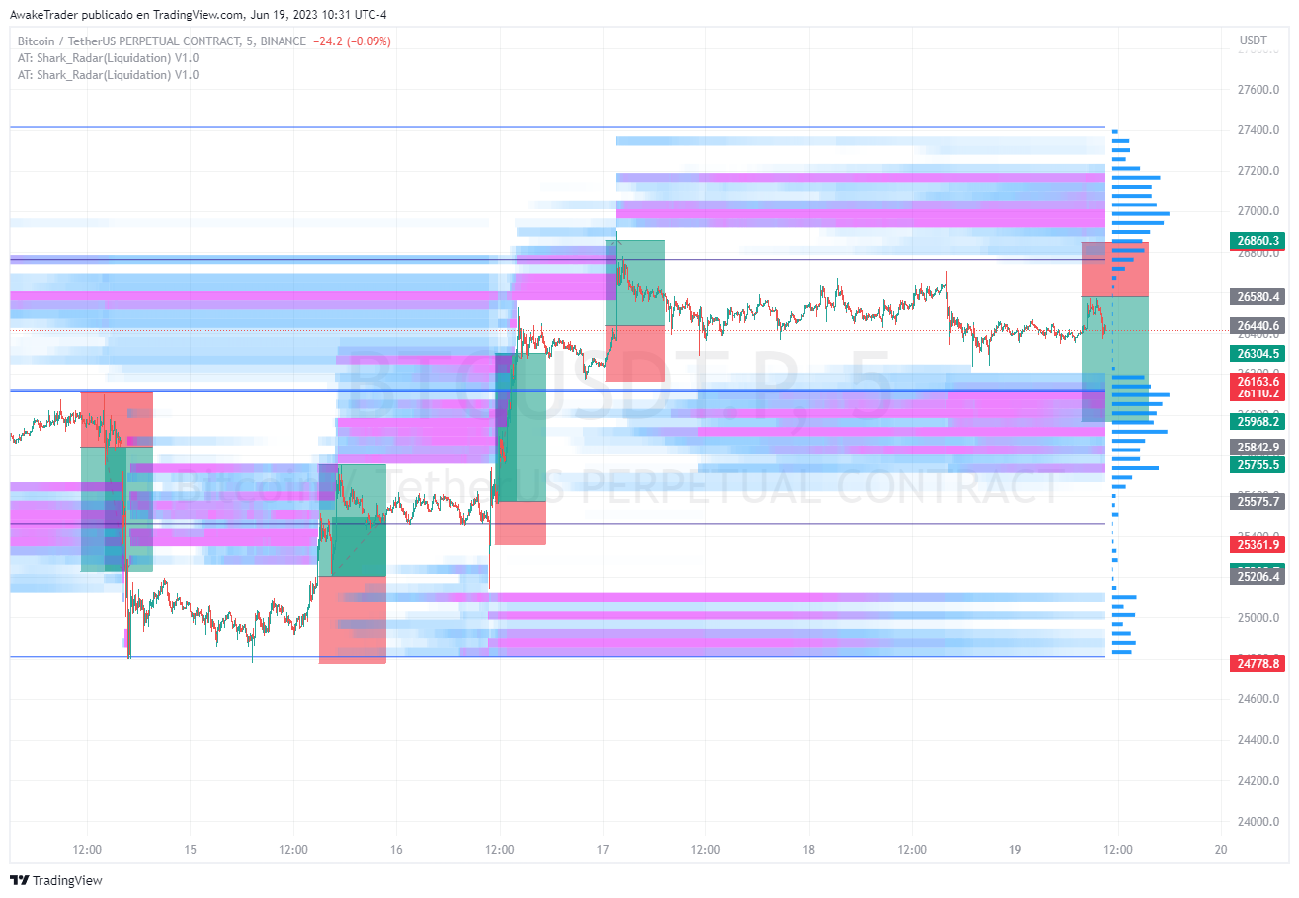

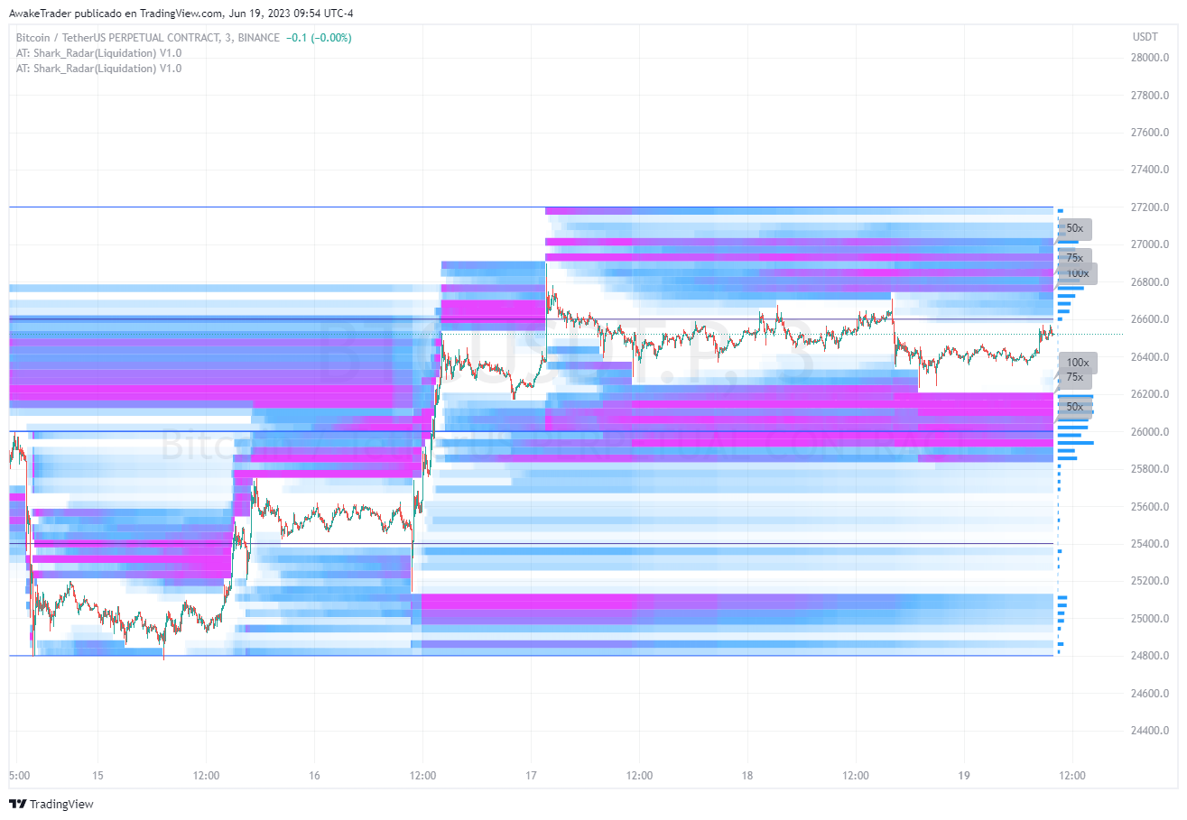**IMAGES:**

